

Asset Type Tree Template – User Testing

**The Goal**

Our goal for this user test was to create a layout for the Asset Type Tree Template, which could also be carried easily across List and Column view.

**The template needed to show all data at a glance, flow well, adapt in terms of device sizing and still translate as a tree view.**

**Current Comments**

The general consent was that most users were happy with the current layout of the template. The need to keep the relational hierarchy was also very important.

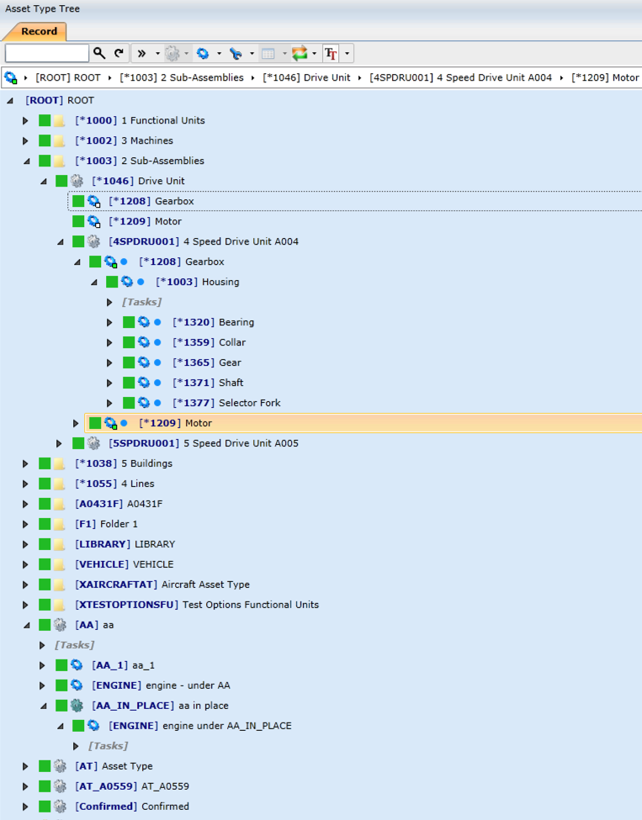

**The User Testing**

Out of a total of 6 designs, I have taken the top 3 that were tested among 5 different users ranging from using OnKey daily, to those who aren’t too familiar with the functionality of OnKey

**Users / Personas**Stefan Swannepool  
Nicolaas Jackson  
Francine Engelbrecht  
Emil Munro  
Johan Hendricks

**The Templates**

The following content was used on all the designs but depicted in different ways on each design: Icon, Status, Inheritance, Code and Description.

**Option 1**



This is the current tree view template

**Option 2**



This shows the status as text and the inherit as an icon below the code and description

**Option 3**



This shows the status, inherit and the icon in a grid below the code and description. The status and the description are in-line

**Option 4**



This is with all the content below as icons

**Option 5**



This is with all the content below as text

**Option 6**



This is with the Code, Description and icons all on separate lines.

**Templates In Context**

Below are the top 3 mock ups with the templates in a tree view.

**Option 1**

**Option 4  
**

**Option 6**

**User Testing Results**

We ran the designs through 5 users allowing them to mark each out of 10 as well as leave some pro’s and cons for each.

|  |  |  |  |  |  |  |
| --- | --- | --- | --- | --- | --- | --- |
|  | Option 1 | Option 2 | Option 3 | Option 4 | Option 5 | Option 6 |
| Stefan | 8 | 5 | 5 | 6 | 5 | 4 |
| Nicolaas | 8 | 4 | 4 | 4 | 3 | 0 |
| Francine | 8 | 0 | 0 | 10 | 0 | 5 |
| Emil | 4 | 6 | 6 | 8 | 4 | 8 |
| Johan | 5 | 6 | 5 | 7 | 4 | 7 |
|  |  |  |  |  |  |  |
|  | 33/50 | 21/50 | 20/50 | 35/50 | 17/50 | 24/50 |
|  | 66% | 42% | 40% | 70% | 34% | 48% |

The user testing showed a reluctance in some to divert from the original template while majority were happy to see some change. Anything with a score of higher than 60% will be the preferred choice.

**Outcome and Feedback**

**Option 4** came out top followed by **Option 1** and then **Option 6**.

Some of the comments for the above options

**Option 1**

|  |  |
| --- | --- |
| Pro’s | Con’s |
| * Compact Rows * All in one line * The icons in a line are easy to follow as you scroll down * Same as OK 5 * Functional quick and easy view * People are use to this | * Feels like not enough info * Needs an update (old) * People are use to this, What is new |

**Option 4**

|  |  |
| --- | --- |
| Pro’s | Con’s |
| * Compact Rows * Like the split between assets and icons * Easy legible * Icons instead of clunky text * Like the icon approach | * Icon based makes it more compact * Might be long if all expanded * Need to figure out a nice flow for the info |

**Option 6**

|  |  |
| --- | --- |
| Pro’s | Con’s |
| * Like the split between code, design and icons * Quick look at Asset Types * Icons instead of clunky text * All info required on one screen * Clear flow of info | * Too big if all expanded * Overwelming * Could fill up the screen quick * Feels like this could be a default option |

**Conclusion**

**Option 4** came out with the highest score, but overall the templates each had their pros and cons. A lot of comments for having all of the templates as a selectable option was made. Users liked the idea of choice.

